Making an LED Blink



Task
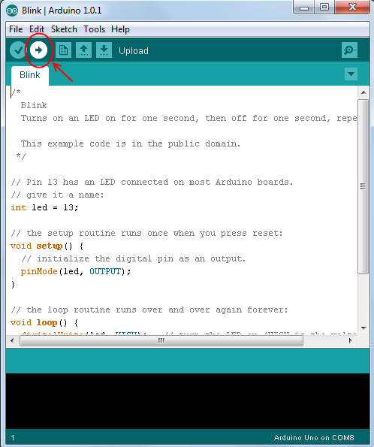
- Create a circuit as shown on next page
- Load up Arduino IDE program on your computer
- In the menu at the top of the arduino program go to 'File → Examples → 01.Basics → Blink'. It should load up some code that looks like the text on the page below
- Make sure the board type and port is set-up correctly in the program, ask a helper if you are unsure about how to do this
- Plug in your arduino board to your computer
- Upload your code to arduino using the upload button (See picture to right)
- Your LED(mini light bulb) should now blink
- Look at the code, play with it by changing lines and then uploading to the board to see what each line does and then figure out how to make the LED blink faster.

Extensions

- Create a traffic light using 3 different colour LEDs and program the arduino to turn them on in the correct order.

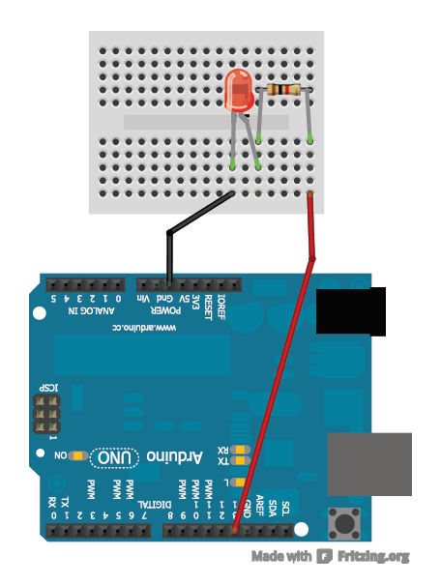
LED only works if plugged into the circuit the correct way round. The longer leg should be on the right.
1K ohm Resistor

Program Code: (File → Examples → 01.Basics → Blink)
int led = 13;
// the setup routine runs once when you press reset:

void setup() {
// tell board that pin 13 is an output.
pinMode(led, OUTPUT);

}

// the loop routine runs over and over again forever:
void loop() {
digitalWrite(led, HIGH); // turn the LED on
delay(1000); // wait for a second
digitalWrite(led, LOW); // turn the LED off
delay(1000); // wait for a second
}

setup() and loop()

So you will see in the code the words void setup() with two curly brackets { } enclosing some code after them and the same with the words void loop(). These two sections are very important and the major difference is:
Any code contained within the curly brackets next to void setup() is run ONCE when the program is started
Any code contained within the curly brackets next to void loop() is LOOPED

So when the program is started, it runs the code in the brackets next to void setup() once and then it will run the code in the brackets next to void loop() over and over again until the Arduino is turned off or reset.
Hence its important to make sure to put your code in the correct set of curly brackets!

